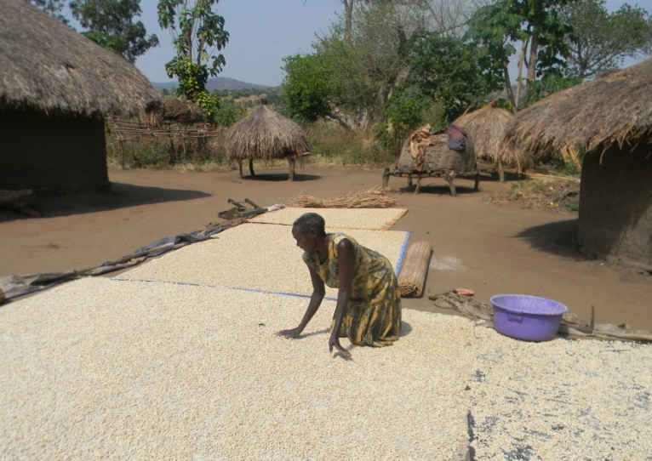

GALS in savings and lending groups

Case study CREAM in Uganda

**Colofon**

Author : Maggie Makanza

Editing : Thies Reemer

Oxfam Novib, with support from IFAD

March 2013

Pictures : Maggie Makanza

INDEX

1. Introduction 4

1.1 Rationale for Developing GALS Case studies 4

1.2 Approach and Methodology to the case study 4

2. Background of CREAM 5

2.1 Organizational Structure and the implementation of GALS 5

3. GALS TOOLS, Training and community action Learning 7

4. Organisational Development through GALS 11

4.1 Household/Individual Level Results 11

4.2 Community/Groups Level Results 13

4.3 Panyani SAGS Group 17

5. Cases 20

5.1 GALS methodology used for planning and empowerment 20

5.2 Single women using the GALS methodology to improve household and community livelihoods. The story if Aneti Alezo 22

5.3 Developing assertive women leaders in a polygamous relationship: The case of Task Monica 24

5.4 Becoming a Community Based Trainer: The story of Wadribo Joseph and Onyisa Victoria 26

5.5 Case Study 5: Unleashing the potential in rural farmers to create sustainable wealth: The story of Margret and Adraleti Natal from Yivo Village, Ombavu parish 28

5.5 BANIBA Self Help Affinity group 30

5.6 Dreams become a lived reality through the use of the GALS methodology and tools-The Journey from the mud hut: The story of Selina and Vincent Adule of BANIBA group in Orapi Village, Omo Parish 32

5.7 Using the GALS tools to take back control for women abusive relationships: The life’s rocky road that MARY Driwaru had to travel 33

1. Introduction

1.1 Rationale for Developing GALS Case studies

The aim of the case studies is to document in-depth qualitative information of how GALS is used at the individual and collective levels in two local farmer organizations/groups in Northern Uganda. The case study intents to highlight what the results of the GALS methodology have been, and identify strategies for further strengthening the farmer organizations using GALS. The case studies are also meant to provide a framework for strengthening the capacity of stakeholders in Zimbabwe and supporting the planning and designing of the GALS pilot later in 2013. Specifically, the two case studies will be used as working papers for the South-South exchange workshop in Zimbabwe through;

* *Sharing experiences of GALS in Uganda with stakeholders in Zimbabwe*
* *Working sessions based on the case studies from Uganda to identify the implications for the context in Zimbabwe*
* *Field practice with GALS to gain commitment from local stakeholders*
* *Sessions to design the pilot in Zimbabwe*

The case study will also feed into the field testing mission led by Linda Mayoux to further review and develop part of the methodology. The participatory review process will enable both community-level participants and staff of farmer organizations in Rwanda and GALS facilitators to look at outcomes and organizational factors and issues, before drawing lessons for scaling up. The case study will also highlight recommendations directed towards institutional sustainability for implementing GALS and the maintenance transformed gender relations in communities.

1.2 Approach and Methodology to the case study

The approach to the case study was participatory and inclusive of all key GALS stakeholders. The consultants first had individual meetings/interviews with the Director, GALS programme officer and trainers/facilitators to get an overview of the programme implementation and overall impact. The Consultants then went out to the field to meet with member of the Panyani and Baniba Savings Groups in Arua District. Emphasis of the development of the case studies was on allowing participants to reflect on their experiences of using GALS and how it was changing their lives at the individual and group level. Feedback was sought on the group learning processes and collective action to identify examples of best practices on GALS. Information was collected through focus group discussions with selected group members and family interviews, analysis of individual journals/note books/charts.

2. Background of CREAM

CREAM started as a member based organisation working with individual farmers who formed an umbrella organisation in 2001 called the Community Organisation for Rural Enterprise Activity Management (CREAM). CREAM provide business development services in the form of selection , planning and management of income generation activities supported by ROSCAS ie rotational savings and village savings and lending associations which developed into community managed CFF. Initially, CREAM was linking farmers to banks but due to limited access to rural farmers and the prohibitive high interest rates eventually led to the establishment of savings and lending schemes by farmers. In addition, CREAM supported has programme supporting adolescent school dropout girls providing training in life skills, hygiene, sanitation, basic rights. They targeted girls as they are most vulnerable as they are more likely to drop out of school due to lack of fees and get married early.

CREAM also focus on issues of food security through promoting summer crops and environmental degradation issues related to the income generation activities that beneficiaries are engaged in, for example, charcoal and brick making businesses. They have been promoting the use of local appropriate technology through the improved cooking stove which makes use of very little firewood, and promoting the use of solar system/panels for lighting.

2.1 Organizational Structure and the implementation of GALS

CREAM operates in all 8 districts in West Nile were most of their target groups are subsistence farmers growing tobacco; sesame seeds, maize, soya beans, cassava and produce shear butter from the shear nut tree. The groups are largely engaged in savings and lending of incomes generated from farming and other entrepreneurial activities. The challenge that CREAM faced at an organisation level, while the savings and credit schemes were popular with communities, there were no observable changes in the quality of lives of beneficiaries. In 2008/2009, they started piloting the GALS methodology with 1 group per sub-county in 8 sub-counties. The piloting began in ARUA district and is now in 3 other districts. Due to loss of staff, there was a period of inactivity following the loss of the GALs programme coordinator. The programme was resumed November, 2011 and is targeting to reach up to 5000 farmers in 3years. Initially when GALS was introduced, there was resistance from farmers as they perceived the methodology as disempowering to men. However, after using the visioning road journey as an entry tool, the level of interest and participation increased.

Subsequently, CREAM has adapted the visioning tool to their manual on business training and using the tool for benchmarking food security indicators in Yumbe and Moyo and generally establishing baseline data on farmers. The methodology blends well with their core business of savings and lending. The GALS tools have significantly helped clarify individual and family raod journeys as well as define the collective objective. Before GALS training, most members would get their share of savings at the end of the year and throw huge parties or buy household consumables. Spouses would each get their share and spend it independently on their own individual priorities. After GALs training, there is a considerable shift with most members setting goals for asset acquisition, housing development and paying school fees among the top priorities. The groups also follow up on individual commitments to check whether members are putting money in support their visions.

**Challenges of implementing the GALS programme**

1. CREAM has to continue managing the community expectation of that they will not receive per diems. Slowly the communities are getting the notion and one remarked that they appreciate getting the ‘*hook and not the fish*’. They continue to motivate the groups through training and having the group stories appearing the CREAM documents, being invited to share their stories.
2. Collaboration with other stakeholder’s i.e. local sub-county and government departments is a challenge as they expect to get allowances when they attend meetings which CREAM does not give.
3. While women are saving more, the groups indicated that their records show that men borrow larger amounts than women. This could be because women reportedly always consulted with their spouses on how much to borrow for their income generation projects while the reverse may not be true for men. Men were also borrowing to finance bigger projects while women were doing smaller projects.
4. There is need to deepen the community dialogue on gender issues. A focus group discussion on polygamy could not reach a consensus with the following issues emerging;

***2.1.3 Enabling Organizational factors supporting GALS***

The following points were noted for CREAM;

* CREAM operations are localised in the West Nile providing finance and business development skills to marginalised communities. There programme focus has been mobilizing communities to form Village Saving and Lending Associations (VSLA). There primary focus has been village rather than household
* There is a high number of men participating in the Savings and Lending Groups compared to groups by CEFORD that started as Functional Adult Literacy group observed which had more women.
* While CREAM programmes target rural farmers, the Savings and Lending groups has attracted professionals living within these communities like school teachers,
* CREAM specifically has an officer designated for gender.
* There is a strong linkage between the organisation and the community through the Community Based Trainers who are part of the organisation and selected from communities to facilitate programme implementation monitoring and evaluation.
* CREAM has adapted the vision road journey tool into their manual on business training and the programme targeting young girls.
* CRAM is an organisation founded by community business adviser and have capacity to provide training in business development, savings and lending and
* There is good collaboration with other NGO partners operating in the same district at the programme implementation level i.e specifically there is a complementary relationship between CREAM and CEFORD on the FAL training. CREAM is getting support from CEFORD to implement the FAL training for their savings groups to augment the business skills training.
* CEFORD is a gender balanced organisation in their leadership and governance structures.

3. GALS TOOLS, Training and community action Learning

The participants that we met were mostly members of the savings and lending groups participating in the GALs methodology. At some of the homesteads visited, neighbors and subgroups i.e. a farmer group also attended. Most members of the group had received their training from CREAM coordinators and community based trainers. Most group members indicated that they had gone and shared the GALs training with their families, individual groups that they belong to or new group members.

* ***The commonly used tool in GALS is the visioning tool***, followed by the challenge action tree and its application to any challenge both social problems at home and crop production/IGA. These two tools are at the core of the GALS programme and were the most widely shared. Most group members used the challenge action tree to analyse the challenges of low crop production and the problem of polygamy.
* The ***pictorial system*** of drawing allows members to cognitively visualise their problems as opposed to writing. One is not only talking about the problem or writing about it, but is also seeing the problem. Hence, visualising solutions becomes relatively easy. All members appear to grasp and understand the tools easily without requiring much education/literacy. Hence. Participants reported that sharing the information between peers is easy.
* The use of the ***‘circles’*** in the visioning tool has the essence of completion and that anything the individual choose to put inside the circle is important no matter how trivial it appears to others. It also symbolises the element of inclusion and mimics the traditional courts were people usually sit in a circle and discuss issues at the family or community level. Whatever anybody says in contribution to the problem is considered and valued.
* The GALS tools are ***flexible and adaptable to different situations*** (*polygamy, monogamous, orphans, single*) and social development issues (*low production, domestic violence, polygamy, marketing*). The tools are being used as a menu where one selects what is appropriate for them and ***tailor make the tools to their situation***. Similarly, when sharing, participants are selective in what they share.
* The case study review found that people from all walks of life, both the young and the elderly, poor and middle income, men and women, monogamous and polygamous relationship are using GALS. Therefore, the tools are ***adaptable*** and do not ***discriminate*** by gender, age, disability or level of income. The savings group members are a mixture of people from all walks of life within the same locality (village).
* The GALS tools are being ***used for a veracity of functions*** from structured community dialogue on common problems, analysing individual social and economic problems, structuring family planning meetings, developing community strategies on domestic violence. This is because the communities are finding it easy to adapt GALS tools to their circumstance.
* ***GALS does not require high levels of literacy*** yet is equally appealing to those who are literate. Hence, it can be used with someone with no education or with someone with a university degree, In some groups we found illiterate women from the villages belonging to the same savings and lending groups with primary and secondary school teachers.
* The participants, although they could explain the drawings on their charts, they sometimes confused the various names of the tools and why they were using it. This could be an indication that the tools are many and ***there is scope for streamlining and simplifying*** things for farmers given their time demands.
* ***GALS learning and sharing process***

This was evidenced from the joint family visions and reports of regular ‘*family meetings’* to discuss and plan together. The GALs learning process started with site visits to Bukonzo Joint were also for partner organisation staff, selected farmers and Community Based Trainers(CBT) in 2008. Following the staff training and exposure to Bukonzo, CREAM selected GALS pilot sites in Arua district and trained savings groups. The training was facilitated by CREAM Programmes Coordinators/Officers and Community Based Trainers with the support of the GALS Consultants. From the trained group members, CREAM selected and trained peer educators who were expected to continue training and sharing the GALs methodology in communities. Throughout these phases, a number of learning routes were organized giving the participants opportunities gain confidence using the methodology through sharing their stories.

There had not been as extensive sharing reported as was observed in the CEFORD group. The following could explain the slow sharing observed;

1. Some of the Peer Educators that we met had not trained anyone as yet despite receiving the GALS training in 2008/9.
2. The gap/lull in the programme between 2009 and 2011 could explain/account for the slow sharing of GALS. Should this be a significant factor, it raises issues of the sustainability of the GALS methodology without partner organisation facilitation.
3. GALS tools were shared by word of mouth with participants using their own charts as reference materials. Some indicated lack of training materials like flip charts and note books was a hindrance. A peer educator of the PANYANI Savings Group interviewed indicated had she had shared some of the tools with her neighbours and they got interested and formed a savings group. However, she had not done any GALS training with them because they had no training materials. The group is therefore raising money to buy flip charts and note books. The perception could be that unless one has flip charts and note books to draw your visions and trees, training and sharing will be limited.
4. While the groups are growing, the reported incentive for joining by new members was the progress that they witnessed in members of the Savings and Lending Groups. A comment from the neighbours of Aneti, a single mother living with her parents, as to why they joined her group had this to say ‘*We joined the group started by Aneti because we notice that Aneti always has money, food to eat, nice clothes and even has nice looking skin*.” So maybe the incentive for joining the group is the savings and lending. This may potentially relegate the GALS objectives to the periphery. There is need to ensure effective monitoring of the quality and process of disseminating GALS as there is a risk of losing the gender aspect of the methodology.

4. Organisational Development through GALS

4.1 Household/Individual Level Results

* The GALS tools allow for self-reflection and provide guidelines for action at the individual and household level while allowing for collective thought and accountability for action at the community level.

***Box: A cultural practice causing low harvest***

*Men did not participate in harvesting as it was seen as women’s work. The husband would therefore invite his sisters to come and help his wife with the harvest. While they do not pay them, they have to provide them with meals (sometimes slaughter chickens and goats). At the end of each day, the sisters of the husband help themselves (without asking) to basketfuls of the produce which they take to their own houses, supposedly in compensation for their labour (i.e literally translated as payment for my legs that I used to walk to come and help in your field, for breaking my back working in your field, for my hands and head that I used to carry the produce). The woman could not complain as the sisters feel entitled since the field belongs to their family. Family are sometimes left with very little after the harvest threatening food security and* *impoverishing women whose major source of income is farming.*

* ***Developing local leadership capacity****:* Selected members whose homes were visited have now been appointed to leadership positions in local schools, religious institutions or the local sub-county. Testimonies from neighbours, community leaders (chiefs), and family members attested to their leadership skills and new status of respect in communities. The GALS methodology is creating a safe platform for the development of leadership capacity for women.
* ***Developing community agents for economic development****:* The GALS is producing agents of change who, through using the tools, have transformed their economic and social status to become community role models. By their testimonies and what the communities witness of them, they have become powerful change agents as communities know what these members were before and what they are after.

***Improved Communication in Marital Relationships/Reduced domestic Violence:*** In marital relationships, the gender Justice Diamond is making it possible for couple to understand each other and communicate issues better. In general, the attitudes of women, even those in polygamous relationships, toward abuse by men are rapidly changing. While it was widely accepted that it is okay for men to beat their wives as a sign of love, this practice is being shunned and groups are developing collective measures to combat domestic violence. For example the Panyani Group reported a reduction in reported cases of domestic violence per week by 90% (from 20 cases to 2 cases per week)

* ***Reducing household Poverty***

There is an increase in the reported numbers of income generation activities and increased levels of savings by the groups. This is partly due to the fact that the groups have seen an increase in their membership and partly due to members increasing their weekly contributions to savings. There is increased crop production due to increased acreage, improved farming methods and joining labor forces. Communities are also slowly dialoguing on cultural practices that affect production.

* ***Ownership and Control of Assts***

A significant change/milestone being celebrated from the implementation of GALs is the empowerment of women to own assets and keep the money they generate from their crops. An example was given were the ‘*men would come to the market and sit at a distance watching the woman sell peanuts. Once a customer comes to make a purchase, the husband comes and gets the money*’. So the woman goes home at the end of the day with nothing. But this is changing as we heard stories of women buying their win assets like goats and jointly making decisions relating to income and expenditure with their husbands.

* ***Men Doing “Women’s Work”***

It was considered as taboo to be seen doing women’s worn in the home i.e. cooking, looking after children and fetching water and firewood. Increasingly, men are reported and seen taking up these roles at home. There are also reports of men sharing work in the field traditionally regarded as women’s work i.e. digging, harrowing and weeding and harvesting. There are reports of families/couples planning together and making joint decision on cropping and prioritizing on expenditure.

* ***Improved Family Unity in Polygamous Relationships***: In general, members report increased family unity and improved communication in polygamous marriages. GALS tools are being used as communication and conflict management tool between spouses and between co-wives. It appears that GALS tools are providing alternative ways of co-wives to engaging with each other. This was evidenced of joint family visions and reports of regular ‘*family meetings’* to discuss and plan together. In one polygamous family visited, the husband indicated that he was having a lot of problems with his fourth wife but after she started attending GALS, she has changed and brings home progressive ideas. Because GALS focuses on the future and not the past, it is helping polygamous families accept their reality and rather channel their energies on discussing and building future prospects for their families.

4.2 Community/Groups Level Results

There is consensus among the group members observed that the introduction of the GALS methodology considerably catalyzed the group’s cohesiveness, giving them impetus and new energy to achieve their objectives. While GALS can work with individuals, its potential is amplified were a group is working towards a common purpose. The following points are worthy of note;

1. *The group provides moral support between group members and offers peer-mentoring/counseling and co-learning. There is peer pressure to conform to GALS values and principles reinforced through songs and theatre.*

*Writers Thoughts*

*The cultural practice of polygamy is routed in gender inequality and the perception and status of women in societies. The complex nature of the many relationships in a polygamous marriage* ***(husband with each wife and between the wives and their different status in the marriage****) makes it difficult for gender equality to co-exist. There is a risk that these positive changes in polygamous family unity and harmony between co-wives many have the unintended consequence of encouraging rather than discouraging the practice of polygamy in the communities..*

1. *There is group monitoring and follow-up of agreed individual plans and target,*
2. *The value chain development and marketing (bulking) are an attraction and works best in a group set up.*
3. *The component of saving and lending is a key success factor as it enables the development of value chains can only be done in the group and strengthens the group.*
4. *The groups provide a platform for developing and building a new democratic culture as well as develop skills and opportunities for lobbying and advocacy on development issues.*

* ***Co-Creation of new knowledge;*** The case studies found that there is the co-creation of new knowledge and group norms. The groups are creating new traditions in communities that embraces the GALS methodology and the culture of saving. This puts pressure on members to want to conform and adhere to the new group norms. This developing ‘*new culture’* is an attraction to new members as they witness the radical change in their neighbours or family members. It is therefore possible for communities to maintain these behavioral and economic changes through self and peer monitoring.
* ***Self Reliance and Group Inter-Dependence***

The use of GALS is developing a sense of self-reliance where individual families and community groups are *taking responsibility for their own local development issues* as part of the group vision*.* The culture of dependence characterizing most development project was not evident. Instead, there is a culture of inter-dependence at the community level addressing common problems and independence at the individual household level.

* **Group Learning and Individual Differences**

While theGALs methodology allows individual to learn about themselves and change, there are opportunities for group learning based on their individual differences. We observed that there is such a high degree of convergence on individual family visions. These similarities can only indicate that the group members are using their differences as a source of learning creating group synergy. As members share their stories, they openly laughed at each other reflecting an appreciation in a non-judgmental perspective creating a synergy needed to collaborate toward effective change processes.

* **Group Cohesion**

The group cohesion is maintained largely through an unwritten social contract enforced by the mere fact that group members share a common locality and problems thereby benefit from collective solutions. With the introduction of GALS, the groups reported rapid growth and has managed to retain its members with reported losses only through death. This exponential growth may in the long run affect group cohesion when the group becomes too large. The way the groups have managed this rapid growth is by splitting up the group into smaller subgroups i.e. there is Panyani or Baniba Group A, B, C, with 30 members each and with a leadership structure reporting to an apex structure for the whole group. This model should also be used as a framework for information dissemination as a continuous pyramid is likely to become unmanageable and eventually collapses on itself.

GALS is strengthening farmer organisation by making them realize the need to work collectively to influence a variety of issues including market prices, social cohesion and local development issues. Other examples of collective actions include the setting up of a domestic violence committee by the Panyani Group to deal with the issue of domestic violence in the community resulting in with cases reduction in reported cases of domestic violence reduced from 20 to 2 per week; Other examples include joint group income generation through contracts with the local counties for road construction work and provision of catering services and hire out of chairs for local events by the BANIBA Group.

* **Planned Change**

The study observed that the groups were focusing on savings as a vehicle for achieving income generation through farming and other projects. There is evidence of groups being self-managed, self-directed and self-organizing teams. Group identities are forged through such artifacts as songs and dance, uniforms as well as weekly structured group meetings and plans.

* **Public versus Private Life**

The GALS approach of facilitating group process of openly sharing information that is both public and private is a powerful tool allowing for the breakdown of individual facades that often stand in the way of change and in most cases enable domestic violence and abuse of women to continue. While members are allowed to share based on their levels of comfort, due to high levels of illiteracy and the vulnerability of members, some people may feel pressured to disclose information they may as yet not comfortable to share in a group. It is therefore important to further develop the groups to be able to manage cases that may require further counseling to allow for emotional healing in cases of abuse. For example, one member of the Baniba group who has been identified and selected as a CBT has not shared any of the GALS tools. On further inquiry, it emerged that she is still dealing with serious personal problems of abuse in her relationship with her husband. While she shared openly and the other group members have been trying to help, they are not equipped to provide counseling. For ethical reasons, the programme should consider additional support as part of the CBT training, counseling skills to help members who open up on their problems and only to find themselves with no professional help.

Writers Thoughts 

Self Disclosure of sensitive private information shared in a group can land itself into abuse. There is need to be cautious and groups should develop some code of conduct and guidelines on what they share outside the group. The long term impact of this level of openness is such closed communities cannot be known.

* ***Empowerment and the experience of choice***

GALS is a methodology that allows for planned change at the community and individual level. It is not an event but a vehicle for collaborative, inclusive, consensus-building change processes. The success of GALS therefore lies in both what is facilitated and how it is facilitated. The facilitation process is key to creating the levels of commitment and buy-in necessary for successful group outcomes. The facilitation process in CREAM GALS groups is mainly through CBT. It may therefore limit the spontaneity of sharing by other members who see themselves as not well equipped to share.

* ***Transforming gender relations at the household level:*** To varying degrees, men in the Panyani and Baniba Groups reported sharing household work with their wives. There are also reports that men are taking up more and more tasks traditionally considered to be women’s work i.e. digging and harrowing/weeding in the fields. While these testimonies could not be verified, they were confirmed by the women as true. What could be measured is the increased understanding of men in the group if gender imbalances and how this negatively affect wealth creation.

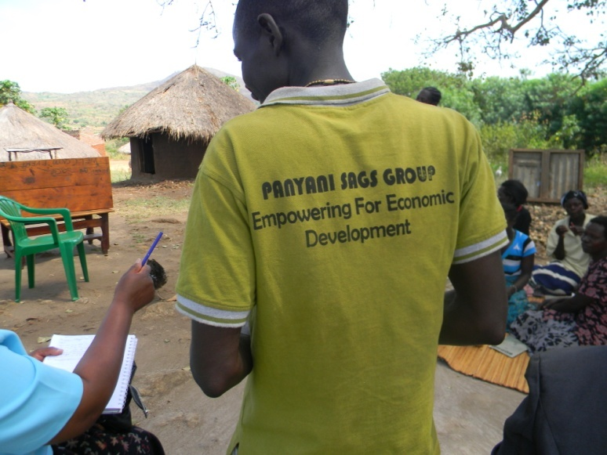GALS is beginning to provide an open forum for men and women to come together and address in a non threatening manner ‘*men and masculinity and gender inequality issues’* entrenched in local traditions and religion. Observed where a significant the number of women deserting polygamous relationship due to neglect or single women formally in polygamous situations. Mentioned continuously was the fact that ‘*we were four co-wives but two are left etc’*. Men also openly admitted in the group forum that polygamy was a burden to them and that those in polygamy have many problems. GALS is therefore producing male change agents, who, through their testimonies are slowly beginning to mobilize other men to change in areas of domestic violence, shared household work and crop production and eventually polygamy.

4.3 Panyani SAGS Group

The Panyani (*which means being mobility in search of survival-if you sit down you cannot eat*) group was founded by 30 members(18 women and 12 men) as a Savings and Credit group. CREAM initially advertised for Community Based Trainers (CBT) whom they trained contracted and asked to go and mobilize community members in their villages to form Savings and Credit Groups. One of the CBT said that’ *After training by CREAM in mobilization skills, went around to churches, market places and other gatherings to recruit members who were in turn trained in Savings and Credit.*’ After two years only 2 members have dropped out and the group increased to 60 members and split into two groups. By 2013, the group now has 90 members divided into Panyani A, B and C. The members in some cases are part of a farmers group or a savings club. Panyani is there an affinity of members from different interest groups as illustrated in the figure below. The group meets weekly under the Okuamani fig tree were the village parliament convenes.

The group is formally registered and has a bank account. There focus is on;

* Savings and credit using the GALs methodology.
* Enterprise selection for collective marketing
* Lobbying government on community development issues.

They have seen a significant increase of their savings since they started partly due to increase in the membership but also due to the increase in the savings value. Initially the group members were saving UGX500 per week and this has increased over the years to UGX1000-UGX5000/ per week. The group members reported that they used not to save any money but now they are saving and have access to soft loans to expand on their businesses. Most reported that although they were savings money, they would spend all their savings and did not invest in assets or businesses that brought more money. After GALS training, having a vision about the future has helped them to invest in bigger business projects like guest house business, trading , increased their crop production as they can borrow money for labor etc The savings are also being used to acquire assets and buy animals as further way of saving. GALs is creating a culture of savings as members are now savings for something specific in their vision. There is better cooperation, financial planning and management of savings by couples. Before GALS training, couples in the group would plan and use their savings separately. Now, while couples are saving jointly, and support each other in making sure that saving target are met. They are also planning and making decisions together on how the savings are invested. Most have also developed joint family visions.

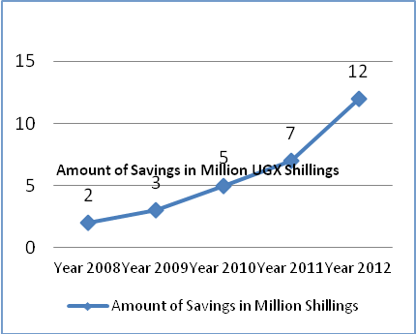

Figure : Savings growth in millions

The group has also seen a reduction in the levels of drinking by men and subsequently reduced levels of domestic violence. The LC1 Councilor reported a significant reduction in reported cases of domestic violence. As the one responsible for dealing with these matters, he used to handle about 20cases reported in 2days per week (Tuesday/Thursday) to the odd case maybe two per week. He is now dealing more with cases of animals destroying crops. He attributed this reduction to the following;

1. There is seen an increase in the number of people joining the Savings Groups as couples
2. 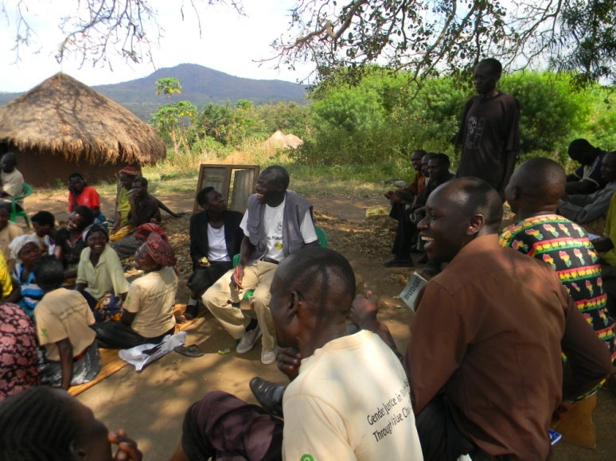The GALS tools are helping people to resolve their own conflicts. ‘*He testified that he himself was a drunkard. He would use the local/village microphone to shout obscenities throughout the night and get involved in a lot of fights. The village elected him as a Councillor before GALS training as a way of moderating his behaviour. He joined the group after receiving GALs training and has also brought his wife to the group. He is now a well respected member of the community,*

Some of the group members in Panyani are teacher from the primary and secondary schools in the community (six of them attended the meeting). The teachers reported that they are using the vision road journey to motivate their children to think on what they would like to become. They are also using the tools to empower and develop leadership skills of school prefects, especially girls, to make presentations during assembly. In secondary schools, the teachers are using the GALS tools for career guidance as a way of preventing school drop out of girls, encouraging girls to do math and science. The group members also indicated that they are transferring the culture of saving to their children through buying them animals like goats and children which they can breed. They are also encouraging their children to grow their own crops whose produce they can benefit from.

5. Cases

5.1 GALS methodology used as a planning and empowerment tool:   
The story of Bako Monica

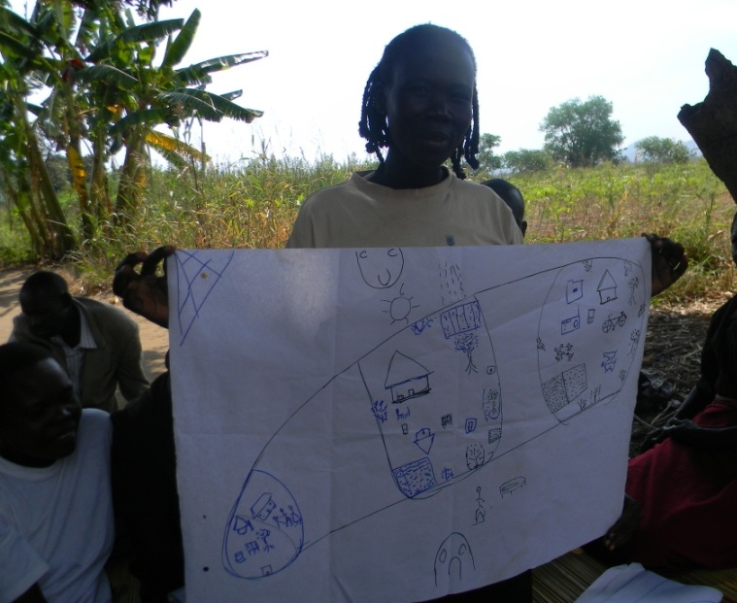Bako Monica is a single mother of five children separated from her husband. She was the second wife in a polygamy relationship with two co-wives. She has been abandoned by her husband who is a policeman and was transferred to Kampala. After so many challenges Monica divorced her husband and moved stay on her uncle’s farm where she and her four children been allocated land. The father of her children does not offer any support nor visit them. Monica looks after her family alone. One day a member from Panyani Savings Group visited her and told her about the group, and was invited her to join so that she can be able to save money to support her family.

After Monica had joined the group, she was trained on savings and business skills, her first share helped her to buy a bicycle for transport a mattress and pay school fees for her children. She used some the other money to pay for field labor. She also attended the GALS training. She is now able to plan for her future life and how best to utilize her resources. She developed her vision and challenge action tree to help her keep track of her plans.

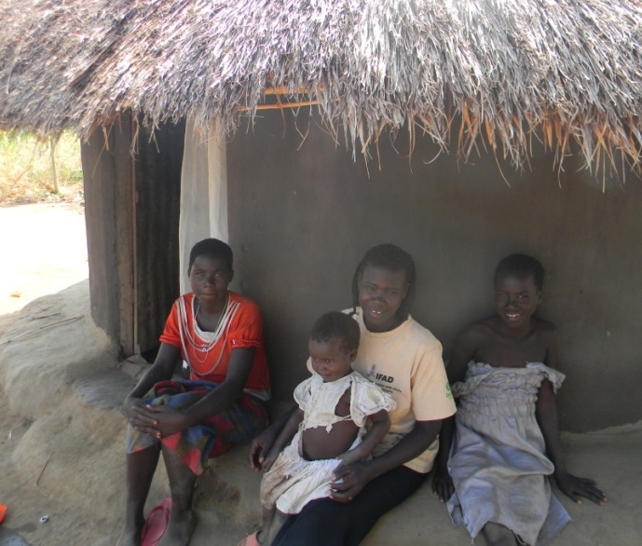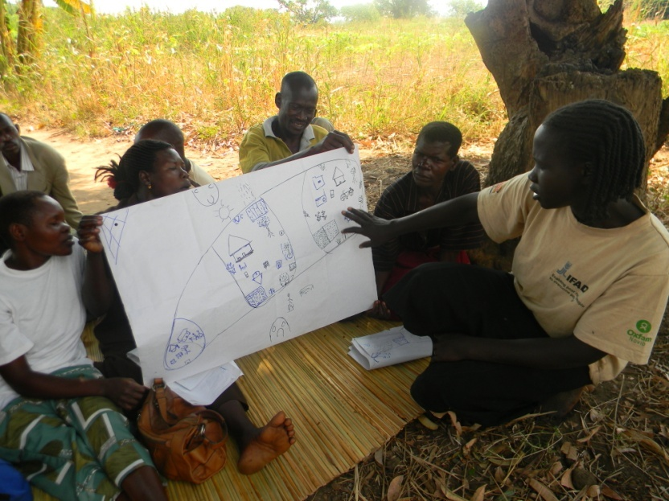She got a loan from the group and a trading business of buying and selling millet and sorghum from her house. She has a weighing scale to support her in the business. The National Agricultural Advisory Service (NAADS) provided her with grafted mangoes. In her vision she want to increase her production by increasing acreage and plant more grafted mangoes, build a better house and educate her children. From her business, she is able to contribute between UGX3000 and 5000/week. In her first year she received UGX380 000 which she used to buy a bed, school uniforms, a bicycle and clothes for children. Her challenge is that she does not have full title to the land that is using. She has to ask permission for any permanent developments or investments that she does on the land. She has a vision to open up more land for agriculture, and buy animals (goats and chickens)

Although difficult as she is now sick, Monica is now able to provide for her children without the husbands support. She uses her profits to hire labour to work in her fields.

5.2 Single women using the GALS methodology to improve household and community livelihoods. The story if Aneti Alezo

Anneti Alezo is a young single woman and a member of the Panyani Savings Group. Anneti Alezo is from a polygamous family 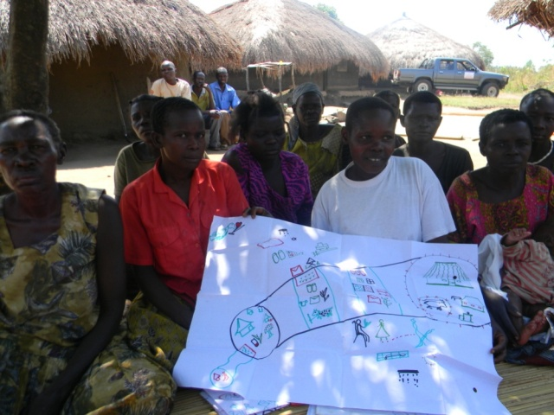of three mothers and her mother is the first wife. They have a family of six members and stays with her parents. She attended school and up to the seventh grade and dropped out of school. She then ran away from home and only returned after falling pregnant when she was fifteen years old. Her mother said that she used to be a very stubborn child ‘*ajiyo*’ in their local language. She joined Panyani SAGS Group after getting the information from the CBT at church. She was very active, understood the methodology well and was passionate about sharing the tools with others. She was then identified and in selected to be a Peer Educator for Panyani Group.

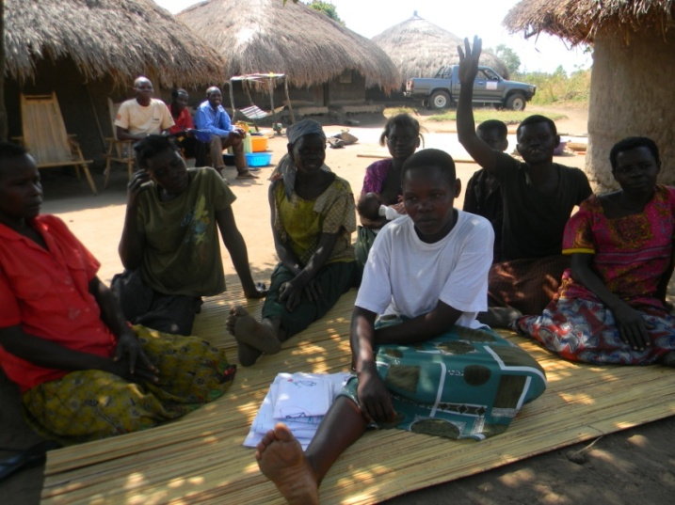Before GALS training, Anneti used to stay with her parents in the same house. In 2009 Anneti attended the GALS training, She shared the methodology with her family members including her steppe mothers Anneti uses GALS methodology tools in all her activities. she do savings as well as training other group members. She has mobilized a group of 60 members called?? who also do savings and share GALS tools with them. In the first year Anneti was able to save a total amount of u.sh four hundred eighty thousands (480,000=)in the second year she saved ush. five hundred thousand (50,0000=) and in the third year she saved ush. Five hundred eighty thousands (580,000=)with all this income she has done a lot developments in her family.

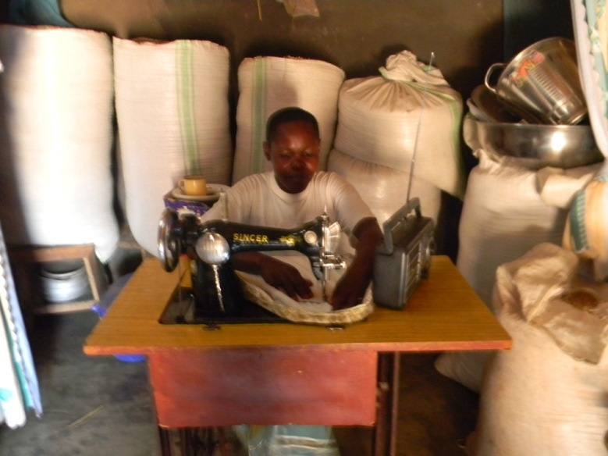First she constructed her own house where she stays, she bought goats which have multiplied up to 25 but eight died due to lack of veterinary service, she bought a tailoring machine for business and attended a tailor’s course, she has acquired most of her essential household equipments and utensils for her personal use, she has a stalk of her own produce of beans of about 200kgs and maize of 300kgs for sale Her home is clean and good, there is food security.

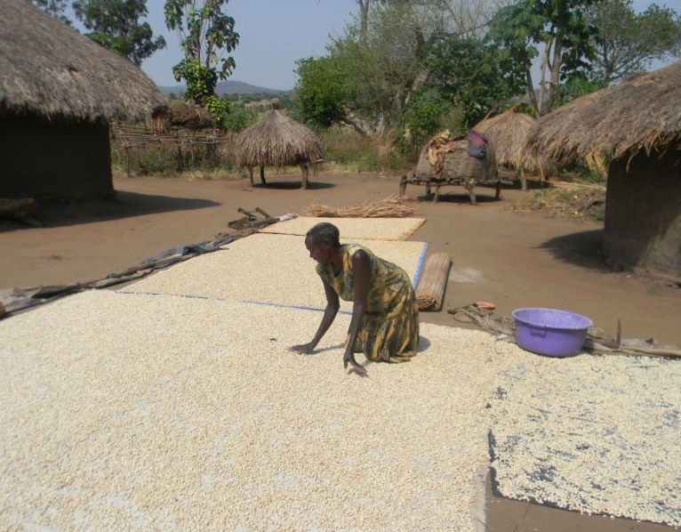Annette’s mother gave testimony about her life and how Anneti has helped the family and improved their livelihood. She plays a major role in the production of food crops for subsistence and for selling.

During our visit the group members testified about the changes they seen since they started their saving group and sharing GALS: woman who used to labor for food in other peoples gardens every day in her life, and her family had only one meal in a day, her family was not ok and the level of poverty was very high. When she joined the group she new nothing and had nothing to save but she was encouraged and supported by the members with the little savings she had, she was given a loan to be able to produce enough food for her family and for sale, her family now has enough food they now eat three meals and their health has improved poverty is reducing slowly by slowly. Annette’s mother do value chain of maize by processing it into a local drink after fermentation, this her main source of income.

5.3 **Developing assertive women leaders in a polygamous relationship: The case of Task Monica**

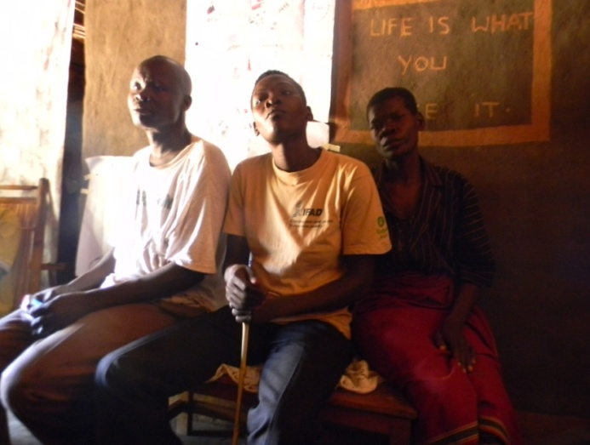When Task Monica came to join the Panyani group, she was seeking a solution to her problem illustrated in the challenge action tree showing a men with five wives. She has four children and is the fourth wife in a polygamous relationship with four other co-wives. Her husband, Mr. Drajua Nikonora Ronald, seen together in the picture above, is a Head teacher at a distant school where he stays with one of the co-wives. Her husband said that Monica was the most difficult and less cooperative of all his wives and was giving him a lot of problems. She was controlling things in the home in a military way and heavy handed in disciplining the children. She was also dependent on me as the husband fior everything. But because I have many wives and children, I could not meet all her needs. Because of this, when she attended GALS training in September 2011, she was finding it difficulties relating with her husband. According to her husband Drajua, ‘*Since joining the Panyani group, she is now not totally dependent on the husband but they are we co-funding the family demands and making decisions together on the family needs and how to fund them. Before, I did not know how she used the money. Now whatever she get from her savings in the group, she comes and shares with me and we plan the money together*’. Armed with the knowledge from she got from GALs training, Monica admits that she has changed the way she relates with her husband and is enjoying a closer relationship than before. She has shared the polygamy challenge action tree and her vision of family unity, with her husband. The charts are displayed on the walls of her living room. She proposed to her that the family start a savings group using the GALS methodology. She is still to share with the other co-wives. When we visited, the 5th wife who was present indicated that while it was her first time to hear about GALS, she is interested to hear more and supports the idea of a family savings group. The husband indicated that they once had the family savings group but it collapsed because of lack of collaboration between his wives. Maybe the GALS methodology will help us discuss issues of developing our family.

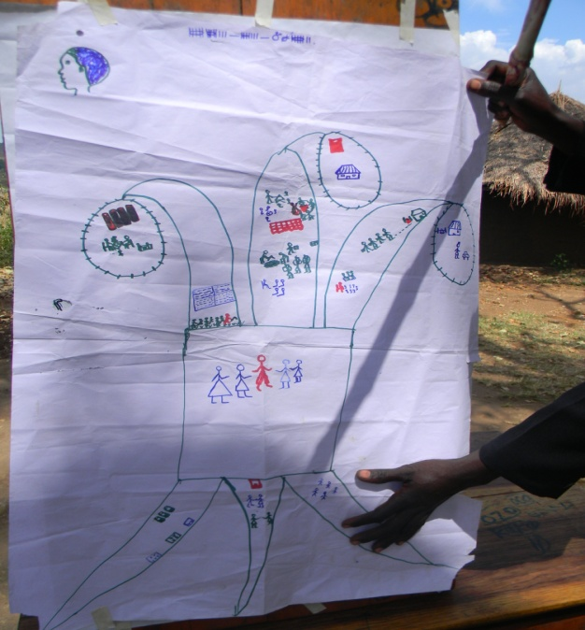

*Presenting the Polygamy challenge action Tree*

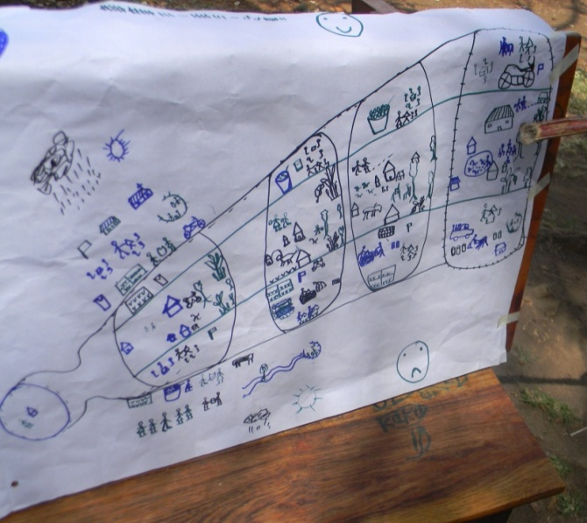Drajua Ronald appreciated the GALS methodology to be the best approach that can change people’s lives and behaviors as he has seen Monica change and now very productive and positive. According to the husband *‘When he married her, she was still in school doing senior school one (first year in high school). She continued with schooling and did the second year of high school but fell pregnant in year three*. *We are planning for her to go back to finish her high school.’* Monica presented herself as confident, intelligent and independent women. This is confirmed by the fact that she has been elected as a sub county councilor after joining Panyani Saving Group in 2011.

*Writer’s Thoughts *

*It is ironic that Taska Monica’s husband is a head teacher who married her as a school going child and lived with her as husband and wife for two years before she got pregnant. She eventually dropped out of school-Pregnant. Now the same man now says she must go back to school-Alas. If teachers who should be torch bearers for keeping girl children in schools are the very one s marrying them, breaking the cycle of poverty through early marriage of young girls dropping out of school is a long way off.*

*Figure 2: Taska Monica presenting her vision*

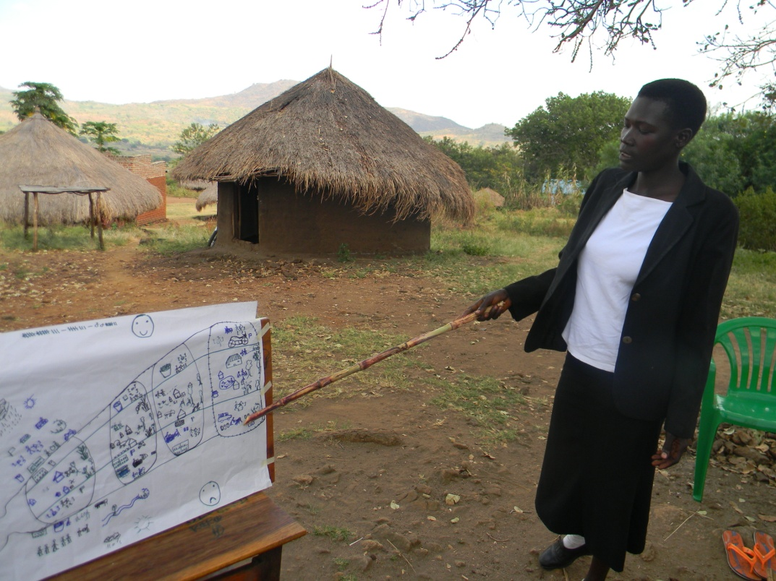

5.4 Becoming a Community Based Trainer: The story of Wadribo Joseph and Onyisa Victoria in their own words.

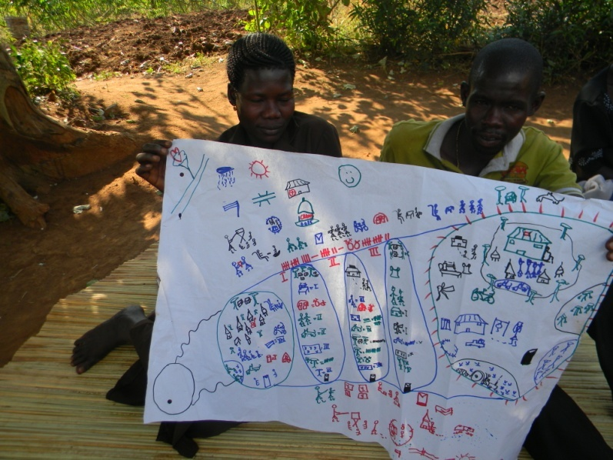 Wadribo Joseph a male beneficiary aged 36 years old a resident of Yivu Village, Ombavu parish in Arivu sub county- Arua district. He is married to Onisia Vita and blessed with four children (3 girls, 1 boy). Joseph is a member of Panyani Self help Affinity (SAGS) group doing savings and credit and is a peer trainer/educator for the GALS/Value Chain methodology. His wife Vita is also a member of the group. Accroding to Joseph, before joining the Panyani SAGS and later attending the GALS programmes, I used not to think much about the future of my family. By that time there were other projects like the ‘entandikwa’-(prosperity for all) being implemented by the government, though the interest of the community people was to get money/safety nets from such projects? I joined one in which we were loaned seedlings for tobacco and after harvesting we could pay back their money with an interest. This was not easy though but we had to survive. The work load of tobacco being heavy even made it worse because it caused conflicts after selling the harvest since much of the work was done by my wife but after wards I would pocket the money. Vita, the wife agreed saying that, ‘*I was fully involved in the processes of growing the tobacco up to harvesting, and when it came to marketing the tobacco, my husband only gave me would a pittance UGX30,000’ .* does not know what happened to the rest of the money as nothing was invested into the family.Joseph admitted that he used to drink heavily and come home very late. If the wife asks me questions there would be a big fight. The situation in my family was terrible as my wife and kids struggled to get food. Even my health was deteriorating as I did not eat properly.

One day in 2009, the Community based trainer a came to his house and convinced him to join the savings and credit group under CREAM in my area of residence. According to Joseph’ *‘I was really troubled that someone had cometo my house to convince me to do soothing. I thought long about it and that day he did not drink. He told his wife about it and they agreed to attend together and join. We then received training in business and savings skills and loan management. At the end of the first year of saving, we shared out the money between me and my wife and I spent my share on myself. My wife also went and bought the things she wanted like clothes, and kitchen utensils. I bought one goat and but drank the 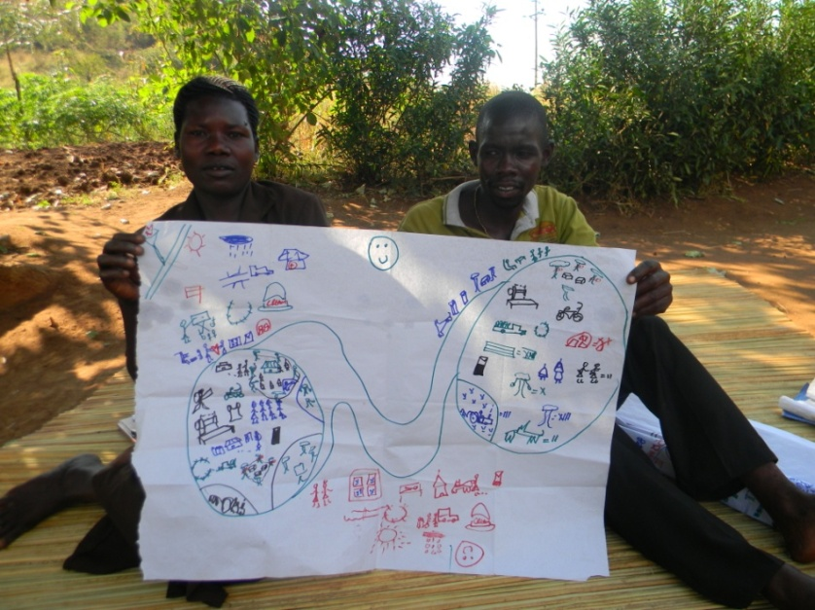remaining balance.*

In 2008 GALS methodology was piloted in our group, but my attitude was a bit negative as I thought that NGOs are trying to give more power to women to overpower us in future. One time, we received visitors from Bukonzo Joint and hearing of their stories made me accept and own the GALS methodology. Luckily enough my wife was part of this sharing of experiences/success stories from Bukonzo. I was touched because their stories resembled my situation at the time.

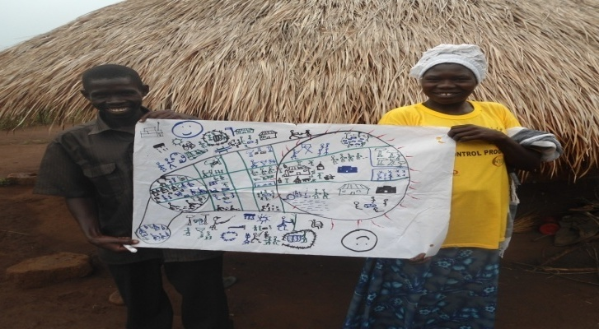I started off nicely by learning the tools and practicing some at home, my wife started becoming pleased with me, because I not only shared this with her but also visitors who came to my house for learning. The tools I have understood and are applying at home are Vision, challenge action tree, achievement road journey, gender balance tree, empowerment maps, market maps, value chain maps. We place them on the wall for others to learn and to constantly remind us.

I have completely stopped drinking and spend more time with my family. Our vision is to build a permanent home. We have bought the iron sheets, roofing timber and are making the bricks now. Through a combination of savings and borrowings, are now planting a short cassava variety for selling and the long variety for food security. We are renting an additional 3acres to increase our crop production. I also doing bee keeping and that is bringing in some money. We have bought a sewing machine for my wife and we are paying for her tailoring course. Joseph has now been elected the Village Community Trainer. I do not miss any meetings for the Savings group.

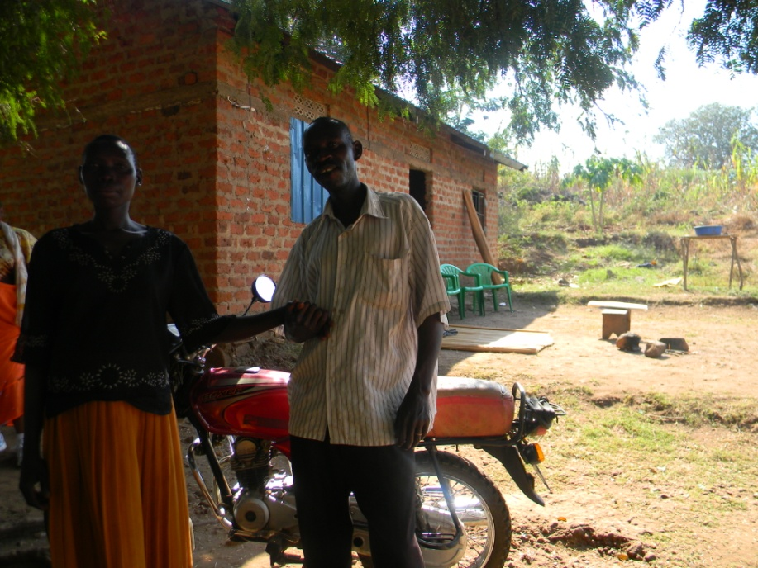5.5 **Case Study 5: Unleashing the potential in rural farmers to create sustainable wealth: The story of Margret and Adraleti Natal from Yivo Village, Ombavu parish**

Draleti Natal and wife Margret Etomaru are residents of Yivu Village, Ombavu parish, Arivu Sub County and clients of Panyani SAGS group. Natal is aged 39 years and Margret is 37 years of age. They are blessed with 7 children, (1 girl and 6 boys) the eldest is in Senior 6. The couple are small holder farmers and supplement their income through bee-keeping. Natal openly confesses of his past ‘*our past was very bad but we are not going to hide it from you, this home you now see, used to be in shambles. I used to drink excessively, batter my wife, I was promiscuous, lazy, a church rebel, and violent’ Margret* concurs with her husband adding that ‘*I used to toil by digging alone at times with the little children, we lacked cooperation and love, because even the children feared their father, we lacked trust to the extent of even hiding money away from each other, there was generally no respect and peace in this home. We did not have enough food, very little income and no savings or assets’.*

*Figure3 and 4: Natal and his wife with their motorbike and the new house in the background and their children*

Margret used to grow crops to feed the family and Adraleti taught senior level 3 at a school near the village, but he resigned in 2008 because of the low income. Farming is not new to the couple, but it still did not generate enough income to sustain the family. Margaret and Adraleti joined the farmer group in their village in 2008 and with CREAM’s support, they received training on business skills.

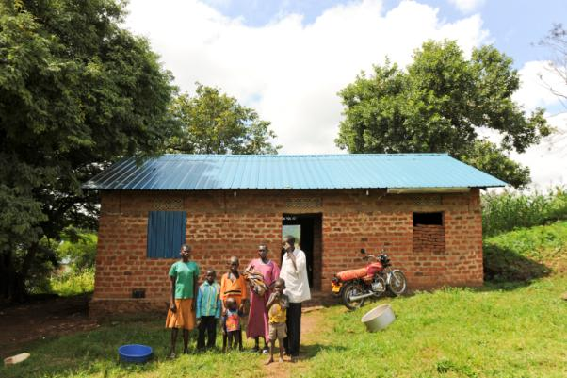

The farmer group is called Okoamani, which means ‘selected by women’. This in itself reflects the continuous behavioral change within the village, in that the voice and role of the woman is respected. This could not be said of the Yivo village two years ago. “*My husband used to drink all the money he earned but now, we discuss what to do with it*,” says Margret. “*We are making decisions together. Our marriage has changed for the better. We always discuss how to spend the money we are now earning, to make sure that we maximize its use. Most of the income is spread between reinvesting in farming, building our new house, sustaining ourselves and paying school fees for the children*.”

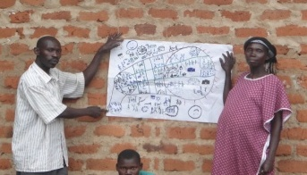Our savings per week has increased from UGX1000 to UGX5000 as a result of working together. We have even acquired a motorcycle from the apiary business and a loan from the group. ‘*We use the motorbike it for various things but mostly to transport farm produce to the market*,” says Adraleti. ‘*Saving the money helps us to decide where to invest*,” says Adraleti Natal. “*We have invested in farming and now most of the family’s income is from it.*” We have a banana plantation with 500 plants, 27 beehives each producing approximately 3-5kgs of honey and bulking sesame and soya beans with others in the farmer group. I have a ready market for the honey in local market in Ediofe at UGX2800/kilo, Juba and Kampala selling for UGX 7000/kilo. Last season we produced 6 bags of ground nuts and produced surpluses from our farm which we used to buy goats that increased in number. We have since exchanged some for two cows, and remain with 8 goats.

Figure 3: Natal and Margret in front of their home

As a result of the GALS methodology, we were able construct a 3 roomed Mabati (iron sheet) roofed house jointly with the share out from our 3rd cycle of savings and part of the loan we borrowed from the savings group. They hope to finish construction of their house in the near future.

In 2011, Margret was appointed as the treasurer of the Okuamani farmers group, which is no small achievement. “*It is very challenging to be a treasurer as it involves handling everyone’s money*,” Margaret says, she is happy to be elected. “*It is an important appointment and I’m very proud to have been entrusted with it.”*

However, this project is not just about increasing family income. For them, it is also about the changes experienced within the family and the home. “*My life has changed*,” says Draleti, “*because I surround myself with people who think positively and want to better their lives*.” Margret see a tremendous behavioral change in both herself and the husband. ‘*He is no longer drinking the way he used to, we now plan together, he now respects my views, and decisions and the children are happy. He even shares the workload at home with me i.e. he baby seats, cleans the house etc* . Margret respects me a lot, imagine she even sacrificed her money to support me educate my own brother who is now employed, something I will never forget, Natal commented. This has been as a result of the GALS methodology.. “*My life has changed*,” says Draleti, “*because I surround myself with people who think positively and want to better their lives*.”

5.5 BANIBA Self Help Affinity GROUP

Baniba Group started in 2009 with 30 member and has grown to 120 members, 69 of whom are women and 41 men. Due to the growth membership, the group savings grew in the past three years from UGX 7mil. to UGX 37mil. with UGX50mil. project at the end of this financial year,

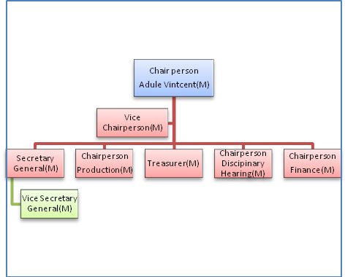

Figure 4: BANIBA Apex Organisational Structure

The group has articulate their vision as ‘*to establish and independent and profitable financial services for increased agricultural production and household income’. Their mission is to provide access to financial services to marginalized rural women and men for increased household income, food security and economic livelihood’.* Ultimately they see themselves transforming into a Village Bank.

They have achieved the following objectives since inception:

* They are registered as local NGO
* Established an office manned by secretary and security guard. They have bought land
* Bought 120 chairs used for meeting and for hire
* Bought utensils for use at meetings and
* Providing catering services for local functions
* They secured a contract with the local council to clear the roads for payment
* Have uniforms
* Have attended GALS Training and other trainings

Future objectives of the Group include fencing the office premises, a motorbike and signposting. A membership fee of UGX17 100 is payable per for old members and UGX21 100 for new members.

The BANIBA structure has 9 elected executive committee members who serve as chairpersons of committees forming the apex of the organisation. All the nine member of the executive are men. The group is further divided into four subgroups of 30 members each referred to as BANIBA A, B. C and D each with its own structure with a chairperson, vice chairperson, secretary, treasury and two money counters. The gender representation in these committees are indicated on thetable given with 5 women and 11 men in all the four BANIBA subgroups. In total women hold 30% of the leadership positions despite the fact that 65% of the group members are women; No women are represented at the apex

|  |  |  |  |  |
| --- | --- | --- | --- | --- |
| **Position** | **BANIBA A** | **BANIBA B** | **BANIBA C** | **BANIBA D** |
| **Chairperson** | M | M | F | M |
| **Vice Chairperson** | TBA | TBA | TBA | TBA |
| **Secretary** | M | M | M | M |
| **Treasurer** | F | F | F | F |
| **Money Counters** | M/F | M/F | M/F | M/F |

organizations were decisions are made with regards to how to invest the money, borrowing and interest levels and disciplinary issues. On further enquiry the men indicated that due to low levels of literacy and fear of speaking in public, the women were reluctant to stand for elections. This was strongly disputed by the women who indicated that they would want to stand for election but sometimes the men hold elections without the women knowing. The women indicated that they are not given a chance as men lobby and campaign for these positions. Women pointed out that sometimes the times held for these ‘meetings’ is inconvenient for them as they live far away from the meeting place,

A few women concurred that they were afraid as they cannot write or do not understand the roles that they have to play and what is required of them. It is important to ensure that women are not further marginalized by men in these groups by insisting on gender balance on election to positions. Training on leadership and governance should be emphasized for women including; the group constitution, rules of conduct of the group, responsibility of office bearers and finance. There is also need to introduce Functional Adult Literacy specifically targeting women.

5.6 Dreams become a lived reality through the use of the GALS methodology and tools-The Journey from the mud hut: The story of Selina and Vincent Adule of BANIBA group in Orapi Village, Omo Parish.

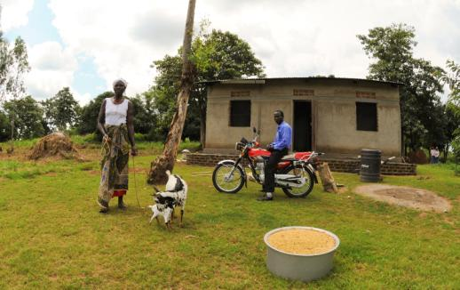

Selina is a farmer and she is 40 years old with no children. Her husband, who is also a farmer, is 49 years old, with 7 children from his previous marriage. In 2009, Selina heard about CREAM microfinance training for the first time. She attended a couple of meetings and she liked it very much.

“I asked my husband to come so he could see as well, and then we both persuaded the trainer to come to our village,” said Selina. They mobilized a group that same year and since then they have been working closely with the local community. “My husband has been a Chairman of the group since 2009, which means a lot to us. The group has great trust in us, as they keep re-electing him.”

It was noted in the case of this couple that the women are saving more than the men. However, the men take out larger loans than the women. The couple has managed to build a shop with a granary for storage, The shop is being rented by the group as an office. They have also built a brick house, bought a motorbike, three goats and six cows. They have increased their harvest of millet, sesame seeds ad soya beans through borrowings. *“I never thought I could be part of anything like this,”* said Vincent. “*My wife went to a (CREAM) group and was interested, so she asked the trainer if he could come to mobilize another group here in our village, and he came. First we were trained on microfinance, later the GALS tools were introduced to us in 2011. With the savings, it helped us to borrow money, and we were able to start planning on how to build a new house.*” Then, Vincent and Selina were living in a small thatched house made from mud. It took them 3 years to get enough money for materials for the new house. We also noted from their records that their savings increased significantly after GALS training as shown in this graph in Fig. 9

“*We’re now able to plan better*,” says Selina. “*We stock the crops until there is a good time to sell it for the highest price. For example, last time I stocked some millet, which we sold at a very high price, so we were able to save a lot more money. The training has given us a great deal of knowledge on how to deal with markets and demands.*” Currently, Selina is stocking shear nuts and thanks to the loans and savings, they have been able to produce more crops each season. This year they planted soya beans, millet, sesame and cassava.

5.7 **Using the GALS tools to take back control for women abusive relationships: The life’s rocky road that MARY Driwaru had to travel**

*I value most the GALS methodology, which has spoken directly to my heart. Our culture here is very male oriented and men describe women ‘useless’ and ‘without brains’. Hence, men do not take women’s views seriously. The GALS methodology is exposing us to see our women differently and men can see these powerful things.” Vintcent Adule*

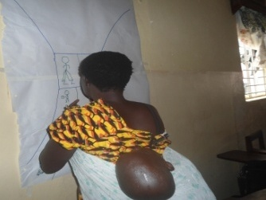Mary was married in 2000 to a primary teacher Mr. Driwaru. She is a mother of four and in a polygamous relationship. The husband is physically and emotionally abusive and does not support her and the children in anyway. She was invited to join the BANIBA group end of year in 2010. Before joining the group, she was making a little profit from buying and selling cowpeas. The little she made was all spent on food for the children. She borrowed money from the group and expanded her business buying more cowpeas and began saving money. However, her problems of abuse at home got worse as the husband hardly came home. She did not know how to deal with the problems at home. Planning how to use the money she got as loans was also a challenge, In 2011, she attended the GALS training programme following which, she developed her vision road journey and challenge action tree. With support from the group member, she got the men in the group to talk to her husband about the abuse and neglect. Since the husband once joined another savings group and borrowed money and did not return it, no group in the area will accept him. So, she could not invite him to join the Baniba group and had no opportunity to share with him her vision. ‘*So this vision is my vision alone’*

Mary appreciates the GALS training which has helped her attain some of her personal and family goals. She started a business of making Malwa(traditional beer) and selling it at her home. She is using this money to save, buy and sell cassava and buy millet for storage. She is now able to pay school fees for her first child and meet cost of medical care for her children.

***What the future holds for Selina and Vintcent Adule***

After last year’s audit of the savings fund, the couple received enough money to buy a motorcycle. “*Here the Roads are bad, so we needed better transport to the market for our crops”,* says Selina. “*We are aiming higher. We want to be better than what we have done. From this year’s savings, We are planning to buy a solar panel which can produce electricity for our house,*” adds Vincent. “*Electricity is a big problem in this area*.” Below are the details on savings by each spouse.

|  |  |  |  |
| --- | --- | --- | --- |
| Financial Year | Husband Savings | Wife Savings | Total Family Savings |
| 2009/2010 | 480 000 | 670 000 | 1 150 000 |
| 2010/2011 | 700 000 | 800 000 | 1 500 000 |
| 2011/2012 | 1,070 000 | 1,200 000 | 2 270 000 |
| 2012/2013-to date(FEB) | 400 000 | 500 000 | 900 000 |

|  |  |  |  |  |  |
| --- | --- | --- | --- | --- | --- |
| **Year** | **Group Saving levels/week** | **Savings** | **Interest on Savings** | **Total Income** | **How was the money used?** |
| 2011 | 1000-5000 | 657 000 | 16 700 | 673 700 | Bought 2 goats, clothes for the children, planned cassava, millet, bought millet and started brewing local beer for sale. |
| 2012 | 1000-1mil | 947 000 | 20 000 | 967 000 | Bought 1 goat, clothes for children, paid school fees for my cousin in senior 2, |
| 2013-todate  5months | 1000-1mil | 428 000 | TBA | Pending | used some of the cash from previous year to start buying and selling cassava and millet for storage(will sell when the prices are good). **I now have 15 goats** |

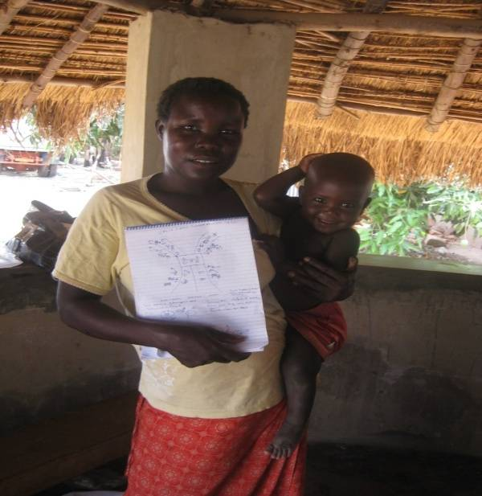Mary states that she is expanding her business and getting better markets through the skills and knowledge she acquired from the group. She has also acquired friends from the Baniba who always visit and encourage her to continue and better herself and for the livelihood of her children. Some volunteer trainers from CREAM have committed themselves to meet the husband and discuss with him about the matter. Mary indicated that her challenge remains that of an unsupportive husband.

‘*The abuse has now stopped and once in a while he brings a bar of soap or some food. But I can take care of myself and the children now. He does not even have a single goat yet I now have 15 goats’.*